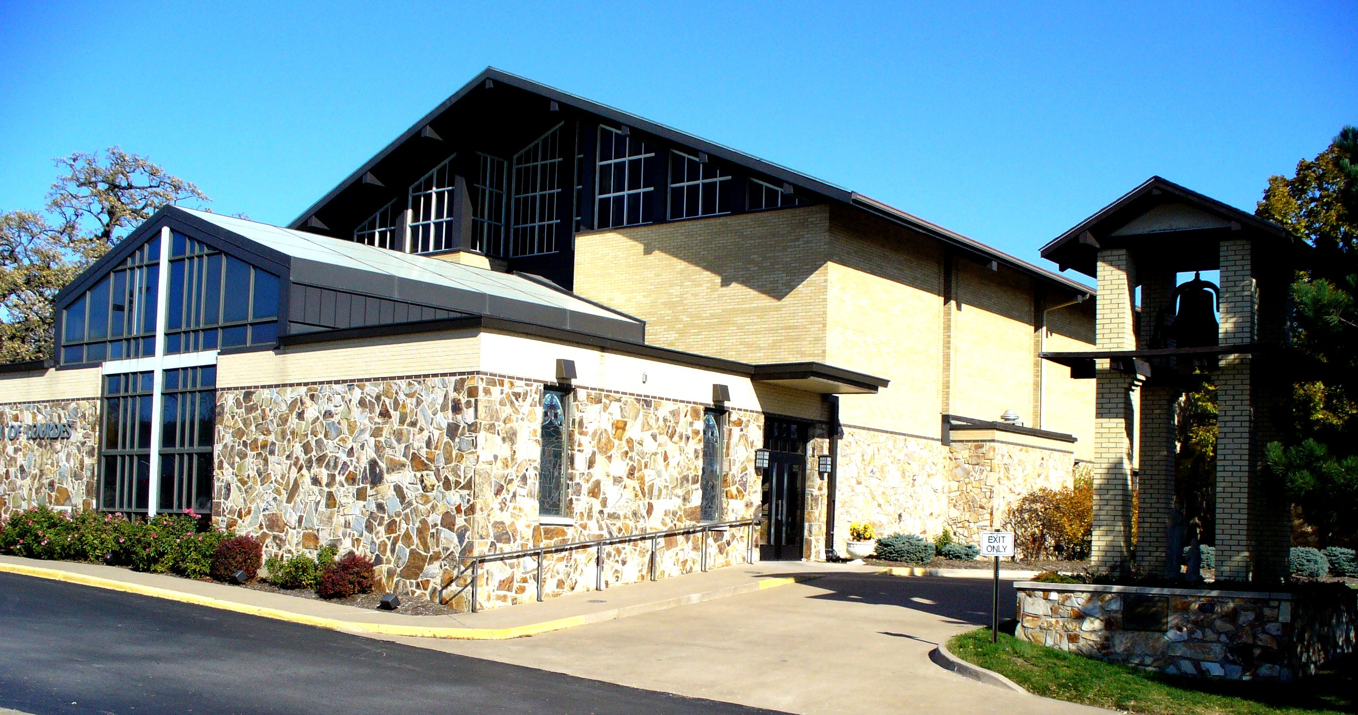  sincere gratituDe from  Our Lady of Lourdes Church & School to the:  - Catholic Endowment of Bettendorf  In 2020 CEBI donated $55,535  These donations covered the cost of new live stream video equipment, Plexiglas shield for student desks, and additional funds for the future building needs of the Church & School.  The total support Our Lady of Lourdes has received since 1994 is $619,379.  www.catholicendowmentofbettendorf.org | The Endowment purpose is to ensure the continuing operation of Our Lady of Lourdes Church & School through defined gifts carefully invested, managed and preserved.  If you are interested in learning more about the Endowment please contact one of the Board Members.  Board Members:  Rev. Jason Crossen,  Brad Boeye,  Greg Adamson,  Chuck Elles, Pat Walseth, Jean Dickson,  Andy Katherman,  Tom Fitzpatrick, and  Larry Whitty

2020 Charitable Gift Idea’s

Give the gift that keeps on giving
- Catholic Endowment of Bettendorf, Iowa

The goal is for the Catholic Endowment to use earnings to fund current needs with original gifts remaining as a memorial for the donor and/or family. Donors are memorialized on a butterfly plaque displayed in the parish gathering space at Our Lady of Lourdes Church.

- Qualified Charitable Distribution

If you have reached age 70 ½ and you would like to help Our Lady of Lourdes Church or Lourdes Catholic School consider a qualified charitable distribution! What a wonderful opportunity to financially support our Parish and/or School. Please talk with your tax professional or investment advisor for more details
Generally, a qualified charitable distribution is an otherwise taxable distribution from an IRA (other than an ongoing SEP or SIMPLE IRA) owned by an individual who is age 70½ or over that is paid directly from the IRA to a qualified charity.

- Support Catholic Education

The Iowa Educational Opportunities Tax Credit is "a winner" for both donors and assisted students. During the 2019-2020 school year, the Mississippi Valley STO is assisting over 600 K-12 students in Scott County!
In 2020, the MVSTO is able to accept donations in excess of $1,324,000! If would like to pledge or make a donation for the 2020 tax year, please visit our Making a Gift page for additional information..

